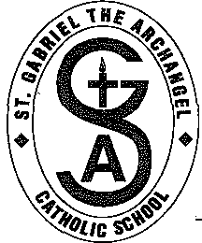
St. Gabriel The Archangel Catholic School

91 Fiori Drive, Woodbridge, Ontario L4L 5S4
Telephone: (905) 856-4155 • Fax: (905) 856-6557

September 24th, 2018

“Safe and Caring School Communities”

Dear Parents/Guardians:

The York Catholic District School Board has a primary responsibility and goal to ensure a safe learning environment for all of our students and staff in our school community.

As part of our safety initiative St. Gabriel the Archangel, along with all other schools in the York Catholic District School Board, will be practicing a variety of safety procedures with students and staff.

This week September 24-September 28, 2018 has been designated as “Safety Awareness Week”. During this week, we will be rehearsing a variety of emergency school procedures to acquaint students and staff with the precautionary steps to take in the event of such things as a warning of severe weather, an intruder or a gas leak. In addition, throughout the year we will hold practice drills to acquaint students with various emergency protocols. Teachers will review these procedures with students in class prior to our practice drills.

If you have any further questions, please feel free to contact the school. Thank you for your support.

Yours in Catholic Education,

C. Sandig
(Principal)

